Work Integrated Learning Internships in Psychology

Janie Busby Grant
James T. Neill
Dimity Crisp
Tamieka Mawer
Tanya Lawlis
Faculty of Health, University of Canberra
Corresponding author email: Janie.BusbyGrant@canberra.edu.au

Target education level: Advanced undergraduate

Acknowledgement: The writing of this resource was supported by the Psychology Education Interest Group of the Australian Psychological Society.

Copyright 2023 by Janie Busby Grant, James Neill, Dimity Crisp, Tamieka Mawer and Tanya Lawlis. All rights reserved. You may reproduce multiple copies of this material for your own personal use, including use in your classes and/or sharing with individual colleagues as long as the author’s name and institution and the Society for the Teaching of Psychology (STP) heading or other identifying information appear on the copied document. No other permission is implied or granted to print, copy, reproduce, or distribute additional copies of this material. Anyone who wishes to produce copies for purposes other than those specified above must obtain the permission of the authors.

Table of Contents
Background Information 3
Resource Overview 3
Evidence-based Teaching Strategies in this Resource 3
Evaluation 4
How this Resource is Useful to Instructors and Can Help Them Become Better Teachers 5
Aims/Intended Learning Outcomes for Educators and Students 5
Overview 5
Program Materials 7
Overview Video 7
Workshops 7
Finding an Internship 7
Assessment 8
References 10
Attachments 12
ATTACHMENT 1: Workshop 1 Slides 12
ATTACHMENT 2: PrePlace Training Module 14
ATTACHMENT 3: Internship Learning Agreement 15
ATTACHMENT 4: Work Health and Safety Site Induction Form 18
ATTACHMENT 5: Marking Rubric: Mid-Internship Reflection 19
ATTACHMENT 6: Log Book Template 21
ATTACHMENT 7: Supervisor Report 22
ATTACHMENT 8: Marking Rubric: ePortfolio 24

Background Information

Resource Overview

This video presentation and accompanying written materials describe the development, introduction, and outcomes of a work-integrated learning internship (WIL) unit/program embedded in an undergraduate psychology degree. The WIL program and its context, drivers, challenges, and strategies are introduced. Key assessments incorporated into the program are presented and examples of WIL placements are described. Outcomes for students, staff, the university, and employers are discussed.

Evidence-based Teaching Strategies in this Resource

In developing a work-integrated learning internship (WIL) program for psychology at our university we started with the National Strategy on Work-Integrated Learning in University Education (Universities Australia, 2015) and the Good Practice in Work Integrated Learning report (Sachs et al., 2017). These guides recommend that universities provide inclusive WIL experiences that offer optimal participation for all students. WIL seeks to address the wider sectoral shift towards fostering closer links between tertiary education and workplace roles, with an aim to provide students with a professional program that integrates theoretical and discipline-specific learning through practice within an undergraduate degree program while simultaneously addressing workforce needs (University of Canberra, 2017a; 2017b). WIL provides the nexus between academic learning and the workplace, enabling students to translate theoretical knowledge within an immersive and authentic practical experience in a professional context, with the aim of being more work-ready (University of Canberra, 2017b).

Internship opportunities were not traditionally available to students in undergraduate psychology degree programs, thus educational leaders have typically not been experienced in providing students with opportunities to develop contemporary skills and experience relevant to the workforce. As a result, undergraduate students often report lacking awareness of the value of their psychological knowledge and skills in diverse employment settings, and relatedly, where they could apply for jobs. Through supervised industry placements, appropriately scaffolded within an undergraduate course, the WIL program aims to better prepare students to commence their professional careers upon graduation.

Our WIL program is framed around a student-centred approach, situated learning theory (Lave et al., 1991), and the four dimensions of Kolb’s model of experiential learning: concrete experience, reflective observation, abstract conceptualisation, and active experimentation (Kolb, 1984; Mortimer, 2017). Students are encouraged and supported to learn by experience and to conceptualise, reflect, and communicate their feelings, experiences, and course knowledge. Kolb’s (1984) model of experiential learning is used to scaffold and embed the program into the undergraduate psychology program while also providing a student-centred approach to learning. Using this model in combination with a curriculum audit process, the WIL unit’s learning outcomes, supporting content, and assessment have been constructively aligned to the program learning outcomes.

The effectiveness of this kind of university-supported workplace experiential learning, particularly as a capstone experience, is well established across multiple disciplines (e.g., Dunn & McCarthy, 2010; Lee & Loton, 2015). In terms of the psychology-specific literature on applying psychological knowledge and skills to professional contexts (Cranney et al., 2022), the argument has been made for WIL’s value in the UK (e.g., Hulme & Cranney, in press; Reddy, 2015), in North American (e.g., Landrum & McCarthy, 2018; STP, n.d.) and Australia (e.g., Bryan et al., 2012; Cranney & Morris, 2018). Hamilton et al. (2018) provide a comprehensive overview of the nature, effectiveness, and challenges of WIL experiences in Australia, with particular emphasis on practical feasibility, which the current resource considers.

Evaluation

Iterative evaluation of the work-integrated learning program was underpinned by Standard 5.4.1 of the Higher Education Standards Framework (Threshold Standards) 2021 (Tertiary Education Quality and Standards Agency [TEQSA], 2022), particularly: delivery with other parties (5.4.1), learning outcomes and assessment (1.4), course design (3.1), wellbeing and safety (2.3), and student grievances and complaints (2.4). A quality assurance matrix, based on the Australian Collaborative Education Network Quality Assurance Framework (TEQSA, 2021), was developed in 2021 to monitor, assess, evaluate, and improve the quality of this program during the three stages of a WIL experience – before, during, and after. In the matrix, the quality of the WIL offered, and the content and assessment of the program is evaluated against four domains: student experience, curriculum design, institutional/faculty, and discipline requirements (TEQSA, 2021). These stakeholders are considered through each stage of a WIL experience.

For each teaching period, feedback against each of these domains has been sought from students, staff, and internship supervisors. Changes have been introduced addressing the concerns raised. For example, initially students felt under pressure by having to find their own internships. As a result, the proportion of staff-sourced internships has increased. To further support students, workshops are provided before, during, and after internship experiences, quality assurance monitoring during internships has increased, and more detailed information has been provided for all stakeholders.

This program provides year-round WIL opportunities. Approximately 190 diverse organisations have provided WIL opportunities, in addition to “in-house” opportunities in other faculties and business units at the university. The Employability Skills Cluster Matrix - Self Assessment Tool (ESCM-SAT; Sambell & Moore, 2017) is embedded into the assessment component of the WIL unit. The ESCM-SAT comprises 24 employability skills represented by 5 clusters: Communication Skills, Interpersonal Skills, Career Management Skills, Self-Management Skills and Academic Skills. Students complete a pre ESCM-SAT (Week 1) then a post ESCM-SAT at the end of their internship. Analysis of pre and post ESCM-SAT from Semester 2 2019 to Summer Semester 2022 for students enrolled in the program (n = 263) showed a significant improvement in all 24 employability skills (repeated measures t-tests on all 24 individual items, p < .001) Table 1 provides the mean total scores pre and post internship on the five skill clusters, with repeated measures t-tests revealing significant differences in scores pre to post internship on all five skill clusters (p < .001). Qualitative feedback from students revealed improvements in self-reported professionalism, personal insight, access to job opportunities, and resilience. Positive impacts on all stakeholders have been identified, including for host organisations, faculty and staff, the institution, and broader engagement/outreach.

Table 1.
Pre and Post Internship Employability Skills Ratings with Difference Scores (n = 263)
Skill Cluster | Pre-internship |  | Post-internship |  | Difference Score
 | M | SD | M | SD | M | SD
Communication Skills | 19.84 | 2.81 | 24.20 | 3.07 | 4.19** | 3.07
Interpersonal Skills | 21.15 | 3.24 | 24.41 | 3.99 | 3.26** | 3.49
Career Management Skills | 8.92 | 2.38 | 11.21 | 2.34 | 2.29** | 2.07
Self-Management Skills | 8.61 | 2.33 | 10.67 | 2.40 | 2.06** | 1.96
Academic Skills | 18.62 | 3.84 | 22.51 | 5.12 | 3.90** | 4.88
**p < .001

The video that summarises this WIL program has been presented at a national learning and teaching conference (Busby Grant et al., 2021) and the program has been awarded an institutional teaching award in 2022 (University of Canberra, Programs that Enhance Learning and Teaching).

How this Resource is Useful to Instructors and Can Help Them Become Better Teachers

WIL is rapidly emerging as a desirable component of undergraduate courses, as a means of improving student experience, self-reflection, practical skills and employability, supporting links with industry, and driving practice-led teaching for universities (e.g., Woods et al., 2020). However, the theoretical and practical processes required to develop and embed a WIL internship program for psychology are often opaque to instructors, and there is a paucity of information on how such programs can be structured and managed. This resource describes a successfully implemented internship program embedded in a psychology program and can be used as a guide for instructors.

Aims/Intended Learning Outcomes for Educators and Students

This resource is aimed at providing practical, structural, and theory-based guidance to instructors who are developing programs to support WIL in their own institutions.

This WIL program is designed to address the following student learning outcomes: (1) Critically reflect on and evaluate the standards of performance and practice expected in the workplace and the profession, and how professional skills and knowledge align with these expectations; (2) Analyse the role and application of theoretical ideas and knowledge in the professional context; (3) Identify and analyse challenges or problems within the work-integrated learning environment and develop appropriate theoretical, ethical, and/or practical solutions to the problem(s); (4) Demonstrate the ability to work effectively with industry and or community based partners; and (5) Acquire, articulate, and apply a range of transferable employability skills.

Overview

This resource consists of a 15-min video discussing the WIL program, its implementation, and outcomes. We suggest watching the video first, as it provides an overview of the program, context, and guidance. The resource also includes a description of the workshops, materials and processes used in the program and copies of key materials as listed below.

- Video Link: Work-integrated learning at the University of Canberra
- Description of workshops delivered in the course
- List of supports and processes to help students find an internship
- Detailed explanation of assessments
  - Assessment 1: Pre-Internship Requirements
  - Assessment 2: Mid-Internship Reflection
  - Assessment 3: ePortfolio
- References
- Attachments
- Workshop 1 Slides
- PrePlace Training Module
- Internship Learning Agreement
- Work Health and Safety Site Induction Form
- Marking Rubric: Mid-Internship Reflection
- Log Book Template
- Supervisor Report
- Marking Rubric: ePortfolio

Program Materials

Overview Video

The 15-minute video, Work-Integrated Learning at the University of Canberra: Scaling up Psychology Internships, was presented at the Australian Psychology Learning and Teaching Conference (2021). Participating in a WIL internship was initially opt-in but is now mandatory for students. Students enrolled in the Bachelor of Science in Psychology (and dual degrees) complete a 120-hour internship during their third year. Identifying and successfully placing students in internships with host organisations has been a challenging and exciting opportunity to engage with local, national, and international workplaces. This presentation discusses the context, drivers, and barriers to scaling up the WIL internship program at UC. Examples of a variety of internships are explored. Assessments of the employability skills of students and other measures collected during the internship are also presented. The outcomes of the program for students, staff and the university are discussed.

Workshops

A two-hour preparatory workshop walks students through the learning outcomes and requirements of the WIL internship program including relevant staff, processes, how the unit fits with the rest of their degree program, how to find an internship, and the assessment. Additional topics include communication strategies with internship supervisors, time management, workplace etiquette, and logistical issues (e.g., technology, workspaces). Students are also provided with guidance about how to get the most out of their internship experience and FAQs for commonly raised issues. General preparatory workshop slides are provided (see Attachment 1).

Two further workshops are provided, one mid-way through the program and one towards the end. The mid-program workshop provides a discussion point for updates on the internship and a review of assessment requirements. The final workshop focuses on steps to take after the internship and upon completing the degree and looking for work.

Finding an Internship

Students are provided with specialised careers support to create a resumé and cover letter. Some students source their own internship, but most find an internship via the university Careers Hub which lists potential internship opportunities sourced by university staff. This is a central, non-psychology specific system which uses Simplicity’s unihub software. Students formally apply for internships in which they are interested, and these applications are reviewed by a program staff member before being passed to employers for selection (which is typically via an online or in-person interview or as preferred by the employer). Note that these internships are not necessarily within the professional psychology field per se; rather, the internships are in employment settings where any undergraduate psychology graduate could apply the knowledge and skills acquired in their undergraduate psychology program. Some examples include:
- Behaviour support in a range of developmental and forensic settings
- Industry-university partnership programs
- Human resources including recruitment agencies
- Government organisations such as health and welfare, veterans and families counselling
- Community organisations including Prisoners Aid and Australian Indigenous student mentoring
- Research projects such as developing mental health promotion programs

Assessment

The WIL internship program includes three key assessment pieces, each comprising smaller assessment components.

Assessment 1: Pre-Internship Requirements
This is an ungraded “hurdle” assessment that ensures students complete all the required safety and protocol processes before starting their internship. This includes:
(a) attending the preparatory workshop (as described above);
(b) completing the PrePlace Training Module (see Attachment 2). PrePlace is a centrally administered online program designed to help prepare students for their internship, covering workplace health and safety, professional behaviour, and workplace dynamics. This module has been provided by the central university careers and internship support service;
(c) completing the Internship Learning Agreement (see Attachment 3). This agreement covers professional conduct, confidentiality, conflict of interest, intellectual property, and workplace health and safety, and is signed by both the student and internship supervisor.
(d) completing the Work Health and Safety Site Induction Form (see Attachment 4).
(e) completing the Employability Skills Cluster matrix – Self Assessment Tool (ESCM-SAT). The ESCM-SAT was created by Sambell and Moore (2017; Sambell et al., 2020) and can be found here. It comprises 24 employability skills representing 5 clusters: Communication Skills, Interpersonal Skills, Career Management Skills, Self-Management Skills, and Academic Skills. Students complete a pre ESCM-SAT before starting their internship, then a post ESCM-SAT when they complete their internship.

Assessment 2: Mid-Internship Reflection
During the internship students are asked to provide a mid-internship reflection of 1500 to 2000 words. Instructions for the reflection are:
“The Mid-Internship Reflection provides you with an opportunity to reflect upon your internship to date. For this reflection you need to submit a reflection that:
- Provides background on the internship organisation, including the core business of the organisation/research centre, information relating to the placement of the organisation/research centre in the local, national and international setting, and key collaborations with industry and community partners;
- Reports and reflects upon the hours and experience completed to date, including what you have been doing in the internship, supervision in the internship, concerns and what is working well.
- Documents your internship communication strategy; and
- Provides reflection on how you are engaging in self-care through this experience.”
The marking rubric for this assessment is provided in Attachment 5. Students are also required to include a mid-internship log book signed by their supervisor (see template in Attachment 6) and a mid-internship supervisor report (Attachment 7).

Assessment 3: ePortfolio

Each student coalesces their internship experiences into a centrally supported online portfolio using the Mahara ePortfolio program (https://mahara.org/) which is integrated into the Learning Management System (https://www.instructure.com/canvas). Students have previously created a portfolio using this platform earlier in their degree. Students are instructed to update that portfolio to include their contact details, a professional photo and a paragraph about themselves including their career goals, final reflection (1700 to 200 words, see below) and any examples of work undertaken at the internship (for example, a paper or blog), images and/or photos. The final reflection instructions are:
“There are two sections to your critical reflection.
1. Reflect on your overall internship by covering the following information:
- A clear explanation of what you did during your internship, what projects you have worked on and how your internship contributed to the operations of the internship organisation;
- The outcomes/deliverables of your internship and the potential impact these may have for the organisation and its future clients/participants; and
- your observations and critical analysis of the industry, workplace and how this influenced your experience - both positive and negative;
- Reflect on the supervision provided during the internship;
- How university prepared you for the workplace;
- What you learned about yourself, your strengths as a professional, and your employability skills -consider these in terms of the supervisor report and the ESCM-SAT;
- Your future career goals and how this internship experience contributed to defining these goals; and
- Provide an acknowledgement of those who supported you while undertaking the internship.
- Review of the client organisation's policies and guidelines relating to marginal groups and Indigenous Australians, how the policies and guidelines are applied in the workplace and the impact upon the student's internship and future career.”
2. Identify and analyse 2 experiences (positive or negative) from your internship and analyse using Borton's Reflection Framework (What? So What? Now What?).
Experiences may be those that:
- did not go well or did not go to plan;
- exceeded expectations;
- involved significant interactions with others;
- led to a significant difference in client/ stakeholder outcomes; and/or
- affirmed or challenged your accepted practice or theory.
In your critical reflection consider the supervisor feedback and the ESCM-SAT. In addition, you need to consider and incorporate citations to literature about critical reflection.
The marking rubric for this assessment is provided in Attachment 8. Students are also required to include a final log book signed by their supervisor and a final supervisor report using the templates described above.

References

Borton, T. (1970). Reach, touch and teach: Student concerns and process education. McGraw-Hill.

Bryan, J., Ranzijn, R., Balfour, C., Tuckey, M., Hayward, R., Pearson, E., Jackman, G., & Lushington, K. (2012). Increasing the work-readiness of Australian psychology undergraduates by changing the curriculum. In S. McCarthy, K. L. Dickson, J. Cranney, A. Trapp & V. Karandashev (Eds.), Teaching psychology around the world (Vol. 3, pp. 164–179). Cambridge Scholars Publishing.

Busby Grant, J. Neill, J., & Lawlis, T. (2021). Scaling up psychology internships [Paper presentation]. Australian Psychology Learning and Teaching Conference 17–19 September 2021, Online.

Cranney, J., & Morris, S. (2018). Undergraduate capstone experiences and psychological literacy. In G. J. Rich, A. Padilla-Lopez, L. K. de Souza, L. Zinkiewicz, J. Taylor, & J. L. S. B. Jaafar (Eds.), Teaching psychology around the world: Volume 4 (pp. 306–328). Cambridge Scholars Press.

Cranney, J., Dunn, D.S., Hulme, J.A., Nolan, S.A., Morris, S., & Norris, K. (2022). Psychological literacy and undergraduate psychology education: An international provocation. Frontiers in Education: Psychology, 7, Article 790600. https://doi.org/10.3389/feduc.2022.790600

Dunn, D. S., & McCarthy, M. A. (2010). The capstone course in psychology as liberal education opportunity. In D. S. Dunn, B. C. Beins, M. A. McCarthy, & G. W. Hill IV (Eds.), Best practices for teaching beginnings and endings in the psychology major: Research, cases, and recommendations (pp. 155–170). Oxford University Press. https://doi.org/10.1093/med:psych/9780195378214.003.0010

Hamilton, K., Morrissey, S. A., Farrell, L. J., Ellu, M. C., O’Donovan, A., Weinbrecht, T., & O’Connor, E. L. (2018). Increasing psychological literacy and work readiness of Australian psychology undergraduates through a capstone and work-integrated learning experience: Current issues and what needs to be done. Australian Psychologist, 53(2), 151–160. https://doi.org/10.1111/ap.12309

Hulme, J., & Cranney, J. (in press). Psychological literacy and learning for life. To appear in J. Zumbach, D. Bernstein, S. Narciss, & P. Marsico (Eds.). International handbook of psychology learning and teaching. Springer.

Kolb, D. (1984). Experiential learning. Prentice-Hall.

Landrum, R. E., & McCarthy, M. A. (2018). Measuring the benefits of a bachelor’s degree in psychology: Promises, challenges, and next steps. Scholarship of Teaching and Learning in Psychology, 4(1), 55–63. https://doi.org/10.1037/stl0000101

Lave, J., & Wenger, E. (1991). Situated learning: Legitimate peripheral participation. Cambridge University Press.

Lee, N., & Loton, D. J. (2015). Capstone curriculum across disciplines: Synthesising theory, practice and policy to provide practical tools for curriculum design. Retrieved from http://www.capstonecurriculum.com.au/

Mortimer, S. (2017). Transforming the student-learning experience: The Triple-V model of experiential learning. Higher Education, Skills and Work-based Learning, 7(4), 337–353. https://doi.org/10.1108/HESWBL-07-2016-0052

Reddy, P. (2015). Preparing for the psychology sandwich placement year. In J. Taylor & J. A. Hulme (Eds.), Psychological literacy: A compendium of practice (pp.46–48). http://eprints.bournemouth.ac.uk/22906/

Sachs, J., Rowe A., & Wilson M. (2017). Good practice report – Work integrated learning (WIL). Learning and Teaching Support, Department of Education and Training. https://ltr.edu.au/resources/WIL_Report.pdf

Sambell, R., Devine, A., Lo, J., & Lawlis, T. (2020). Work-integrated learning builds student identification of employability skills: Utilizing a food literacy education strategy. International Journal of Work-Integrated Learning, 21(1), 63–87. https://www.ijwil.org/files/IJWIL_21_1_63_87.pdf

Sambell, R., & Moore, S. (2017). Employability skills cluster matrix – Self-assessment tool (ESCM-SAT). Edith Cowan University.

Society for the Teaching of Psychology (n.d.). Capstone resource page. https://teachpsych.org/page-1603017

Tertiary Education Quality and Standards Agency. (2022). Guidance note: Work Integrated Learning. Australian Government. https://www.teqsa.gov.au/latest-news/publications/guidance-note-work-integrated-learning

Tertiary Education Quality and Standards Agency. (2021). Higher education standards framework (threshold standards) 2021. Australian Government. https://www.teqsa.gov.au/how-we-regulate/higher-education-standards-framework-2021

Universities Australia, Australian Chamber of Commerce and Industry, Australian Industry Group, The Business Council of Australia, & The Australian Collaborative Education Network. (2015). The National strategy on work integrated learning in university education. https://cdn1.acen.edu.au/wp-content/uploads/2015/03/National-WIL-Strategy-in-university-education-032015.pdf

University of Canberra (2017a). UC curriculum review – Undergraduate program Blueprint. Learning and Teaching, University of Canberra.

University of Canberra (2017b). UC curriculum review – Undergraduate program professional core. Learning and Teaching, University of Canberra.

Wood, Y. I., Zegwaard, K. E., & Fox-Turnbull, W. (2020). Conventional, remote, virtual and simulated work-integrated learning: A meta-analysis of existing practice. International Journal of Work- Integrated Learning, 21(4), 331–354. https://www.ijwil.org/files/IJWIL_21_4_331_354.pdf

Attachments

ATTACHMENT 1: Workshop 1 Slides

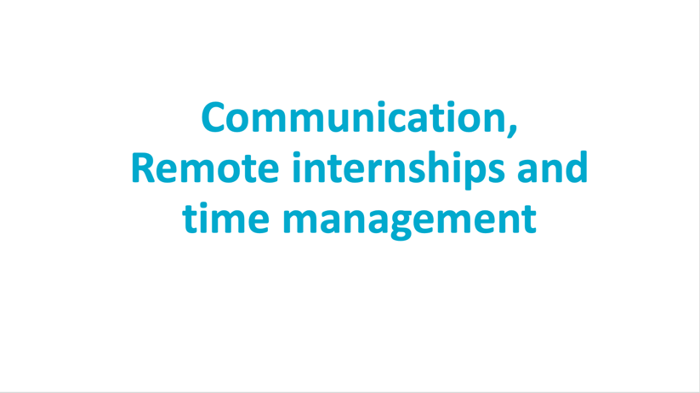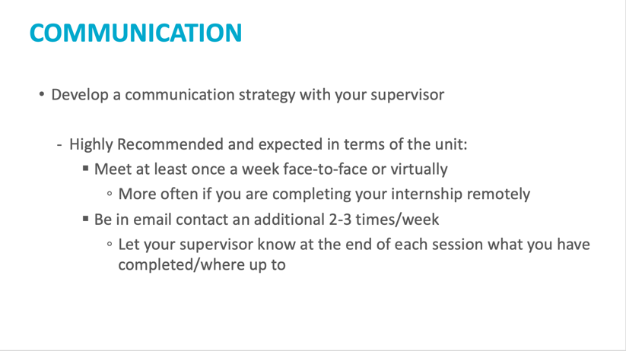

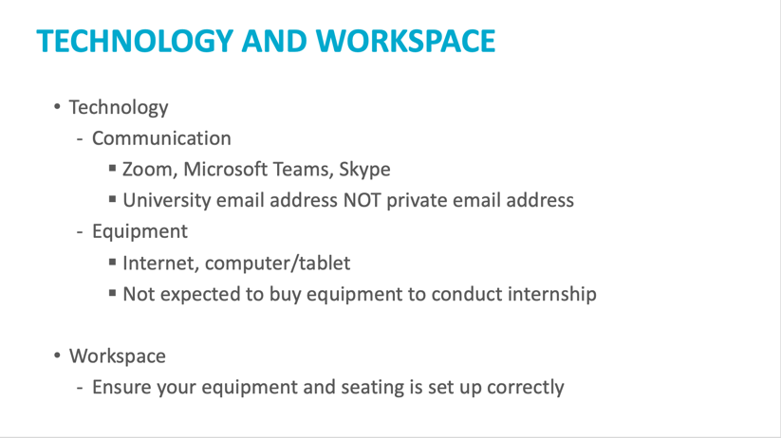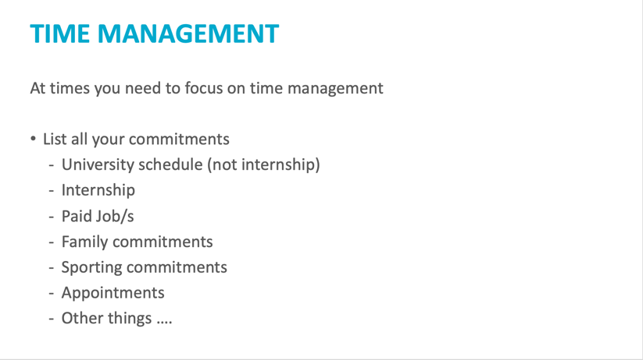

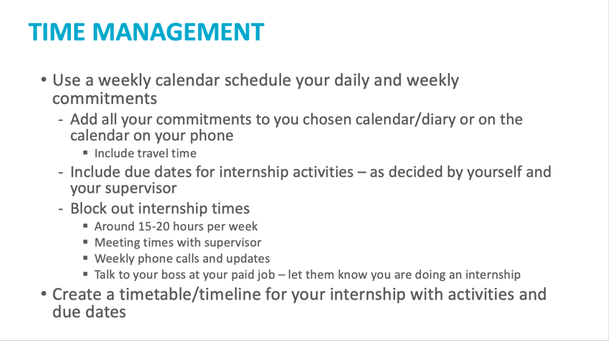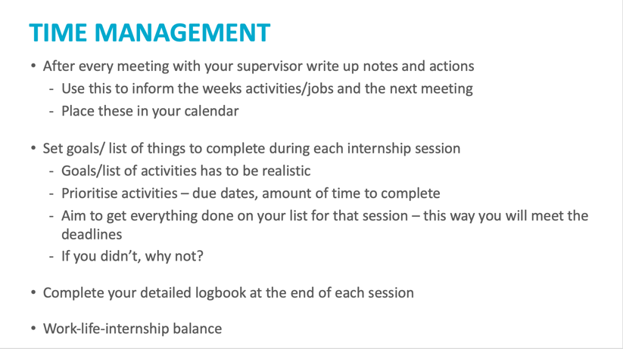

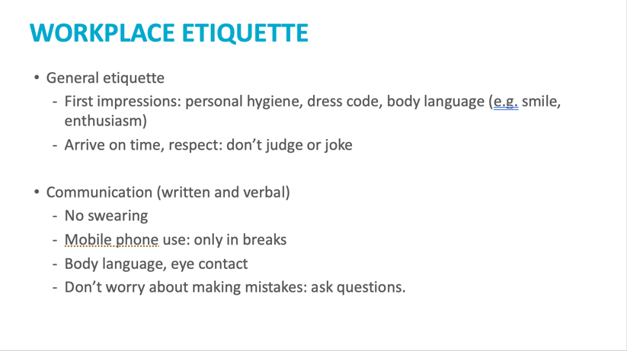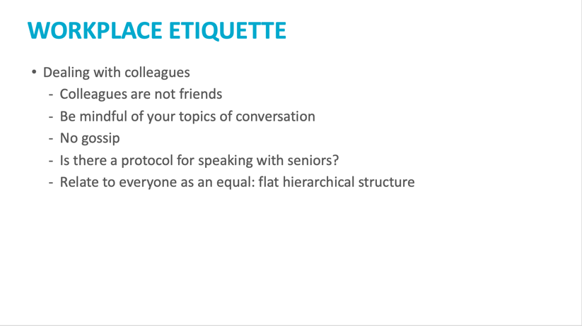

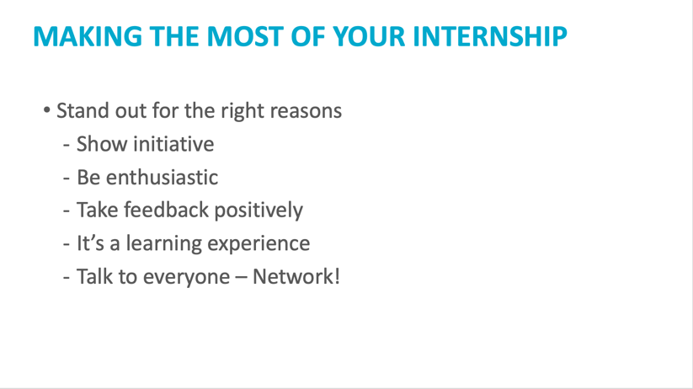

ATTACHMENT 2: PrePlace Training Module

All students enrolled in the WIL course are required to complete the PrePlace Training module. The module is regularly upgraded to ensure the information they receive for WIL (Work Integrated Learning) is current and relevant. The module also includes a mandatory section on Child Safety that all students undertaking a psychology WIL placement are required to complete prior to placement. There are also modules for various study areas. Psychology students complete the ‘Health’ module. Once students successfully complete the module, they will be able to access their digital credential (badge) that they are required to upload to InPlace (https://inplacesoftware.com/) in addition to their other self-submission details.

Module descriptions:
- Module 1 - Compliance and Requirements - This module will provide students with information regarding the policies and procedures that must be adhered to pre, during and post their placement.
- Module 2 - Child Safety and Wellbeing Training - This is a mandatory training module for all students undertaking a placement regarding child safety and wellbeing in a workplace.
- Module 3 - Your placement, your rights! – Covers WHS, Indigenous policy in the workplace, Fair work requirements and workplace violence.
- Module 4 - Make the most of your placement – Preparing students for the placement.
- Module 5 – Mandatory uploads.

ATTACHMENT 3: Internship Learning Agreement

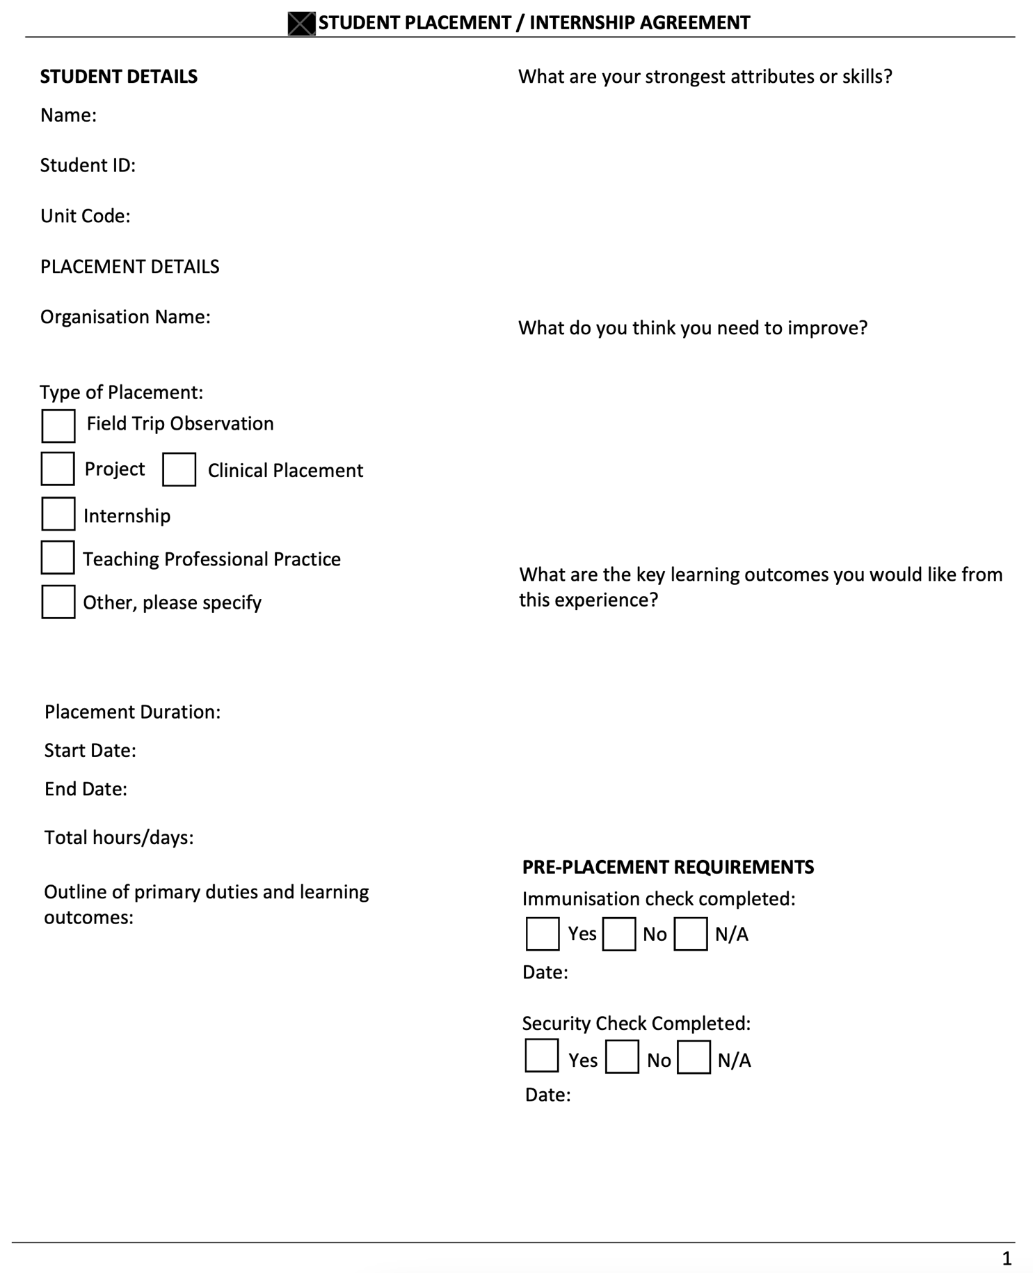
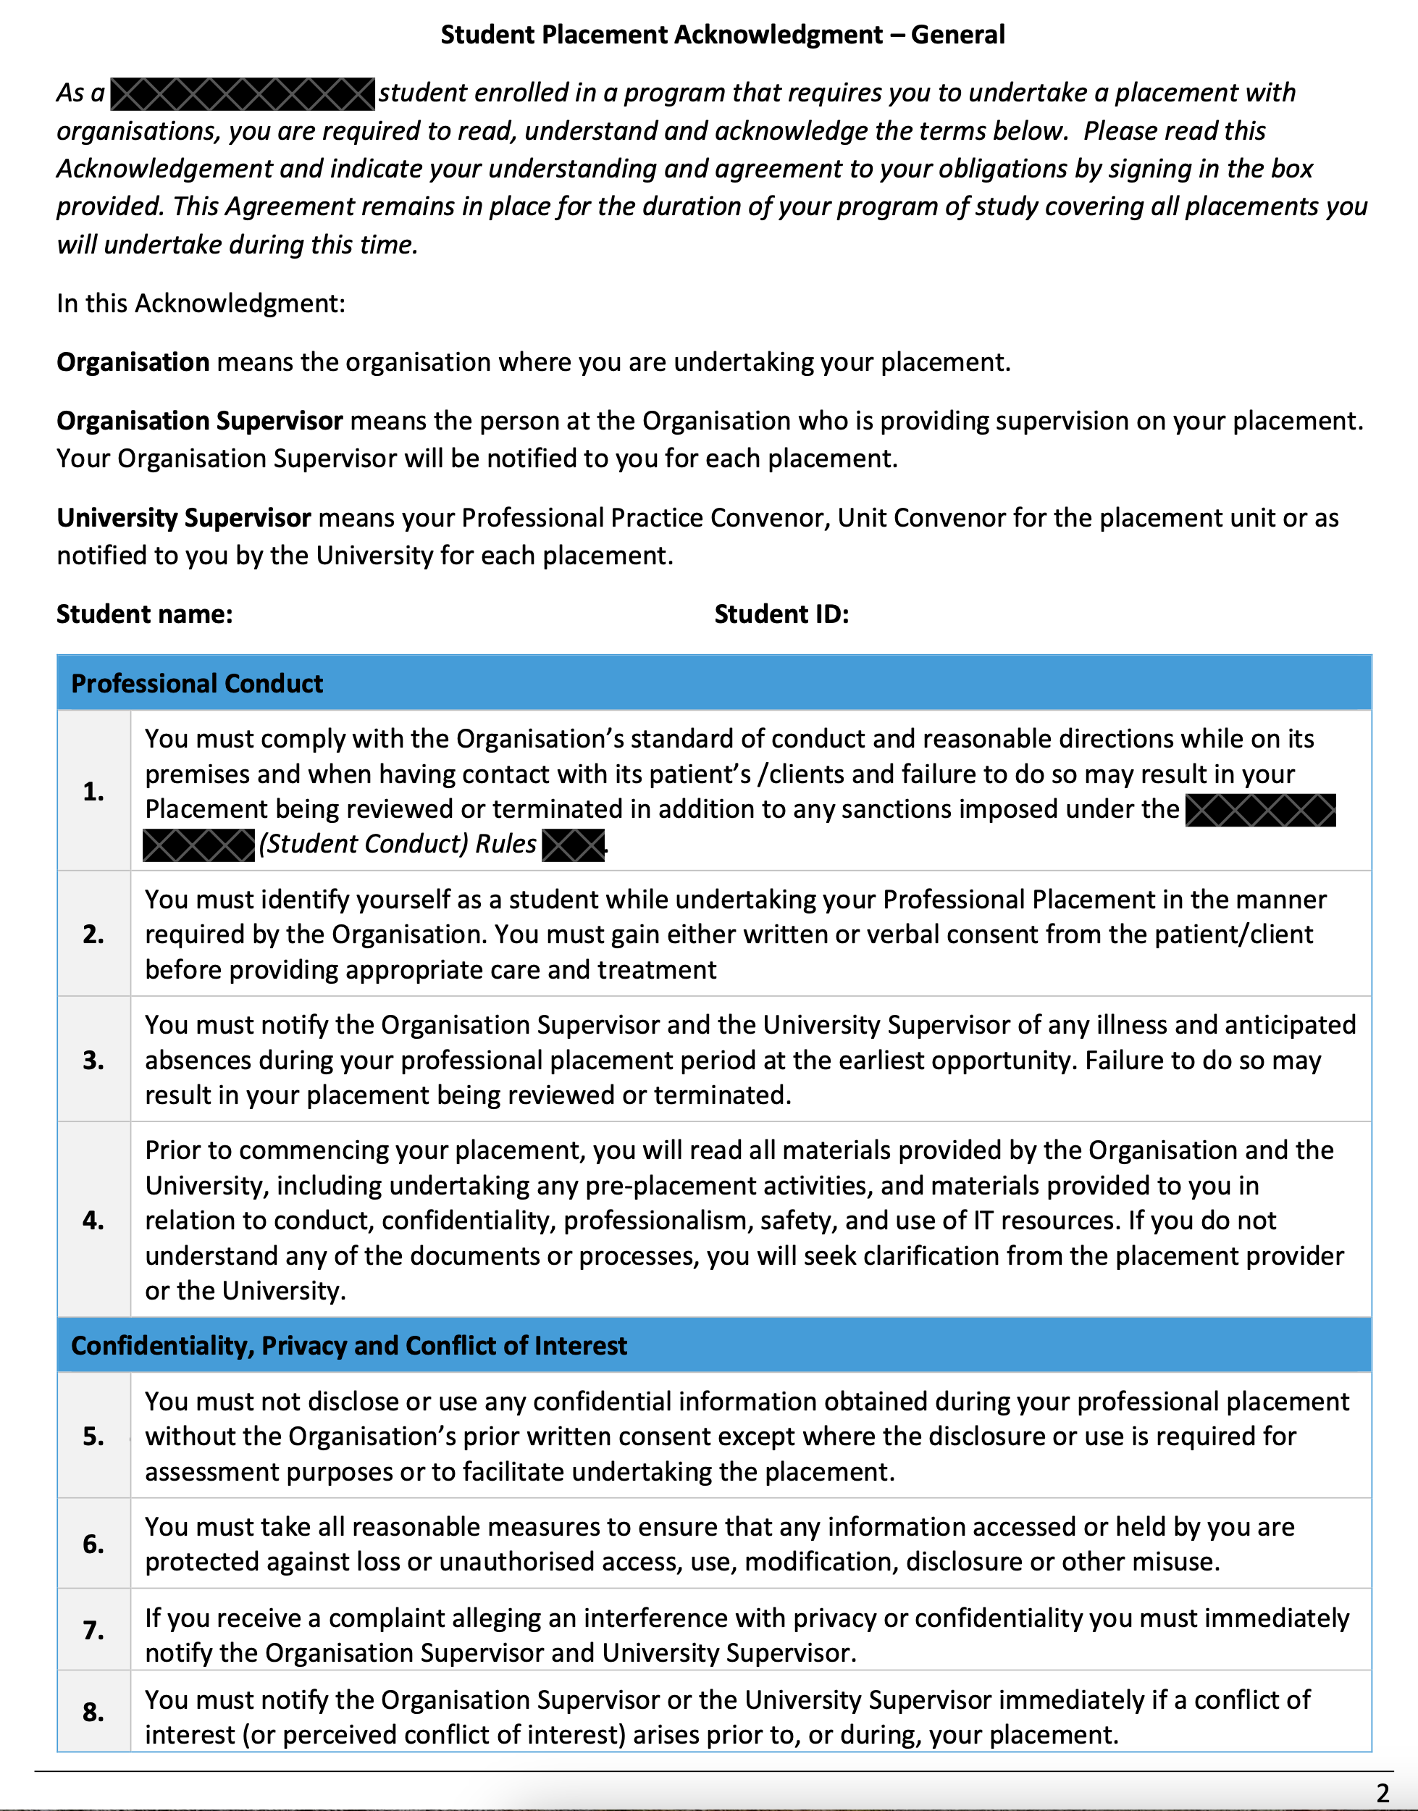
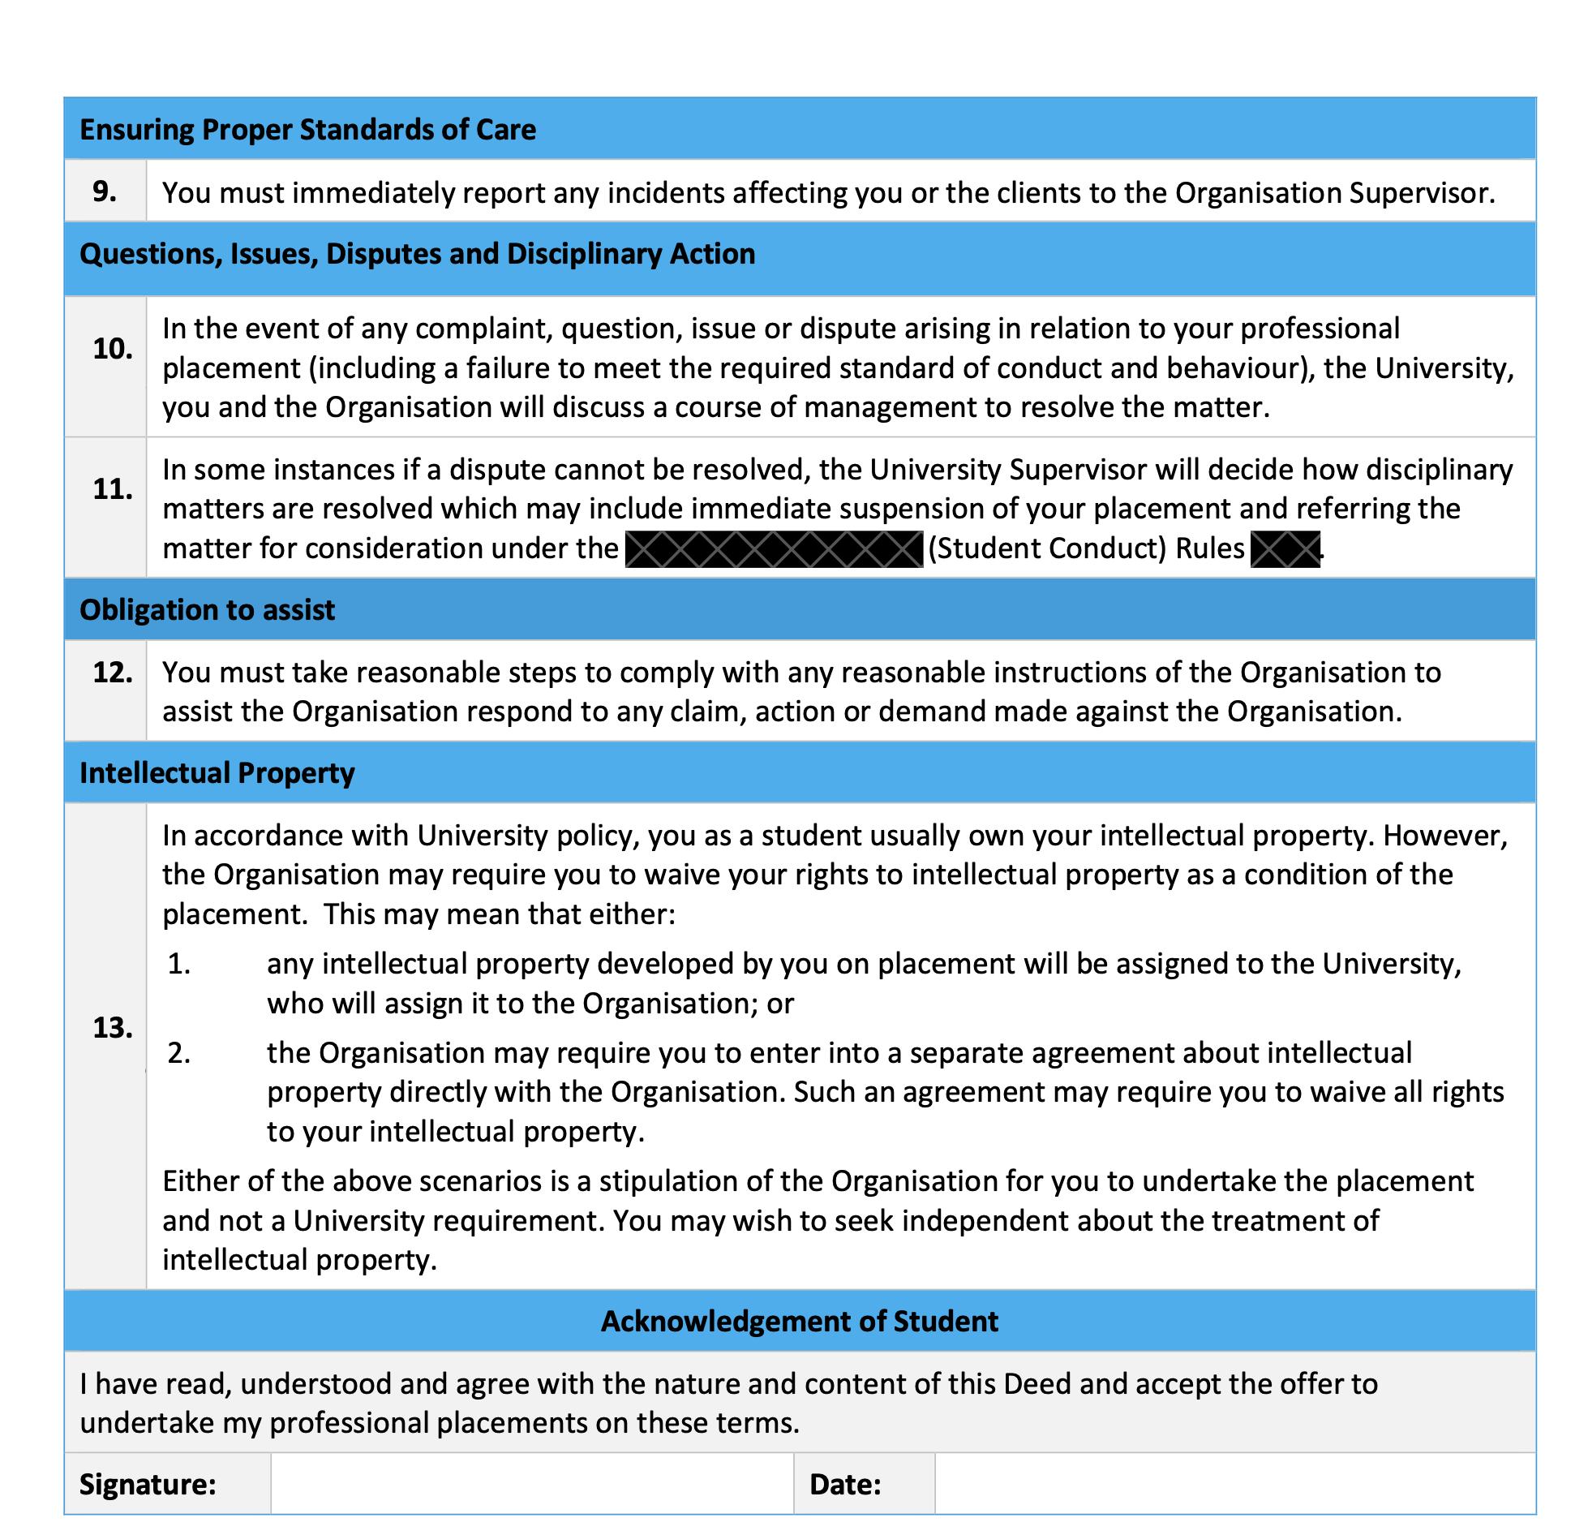

ATTACHMENT 4: Work Health and Safety Site Induction Form
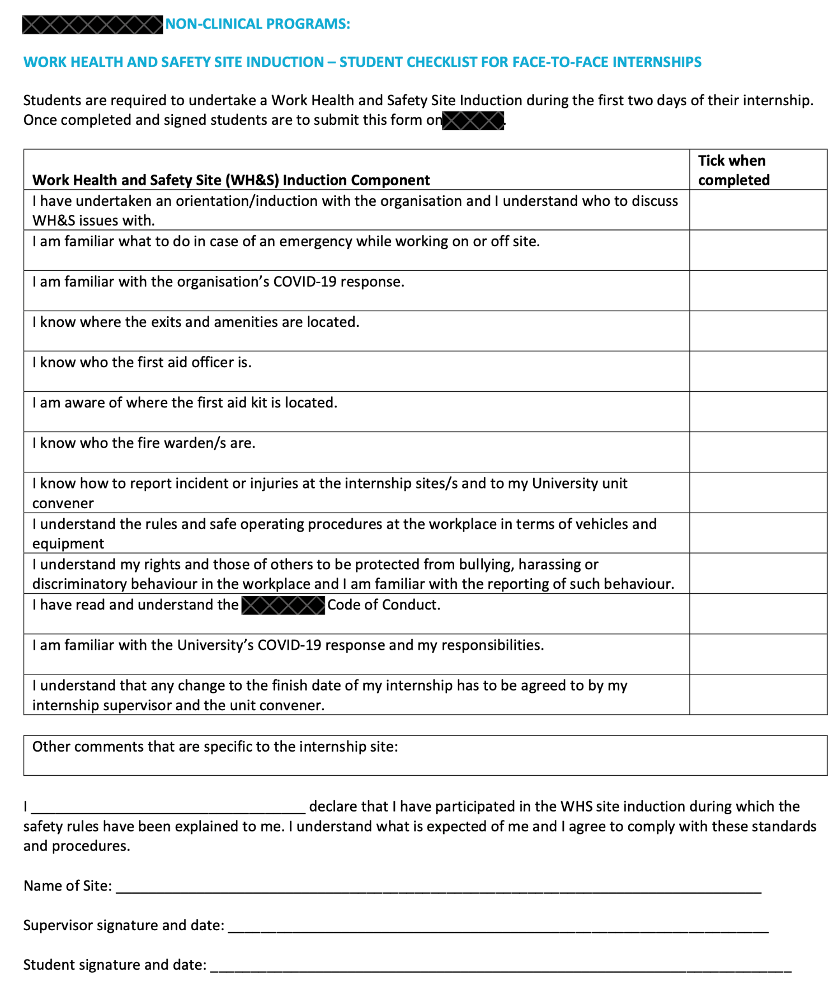

ATTACHMENT 5: Marking Rubric: Mid-Internship Reflection
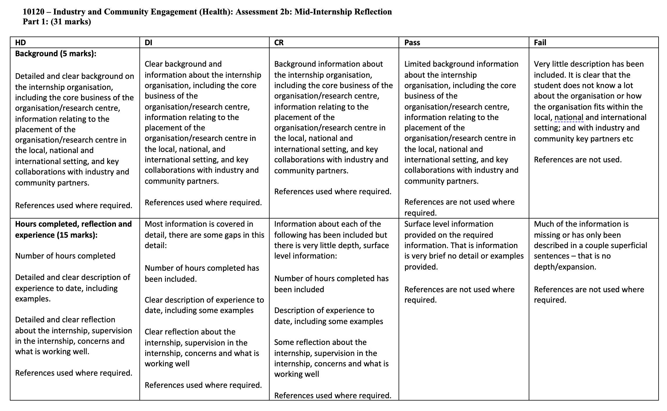
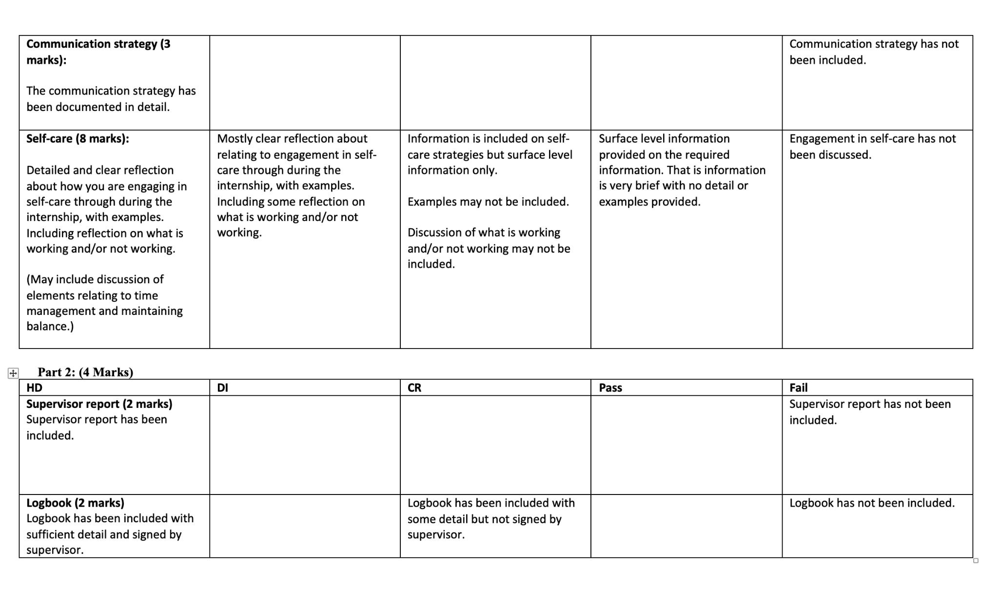

ATTACHMENT 6: Log Book Template

Industry and Community Engagement Log Book
(Supervisor to sign every 30 hours)

Date | Time (from-to) | Hours | Activity details

Total hours:

Supervisor Signature:

Date:

ATTACHMENT 7: Supervisor Report
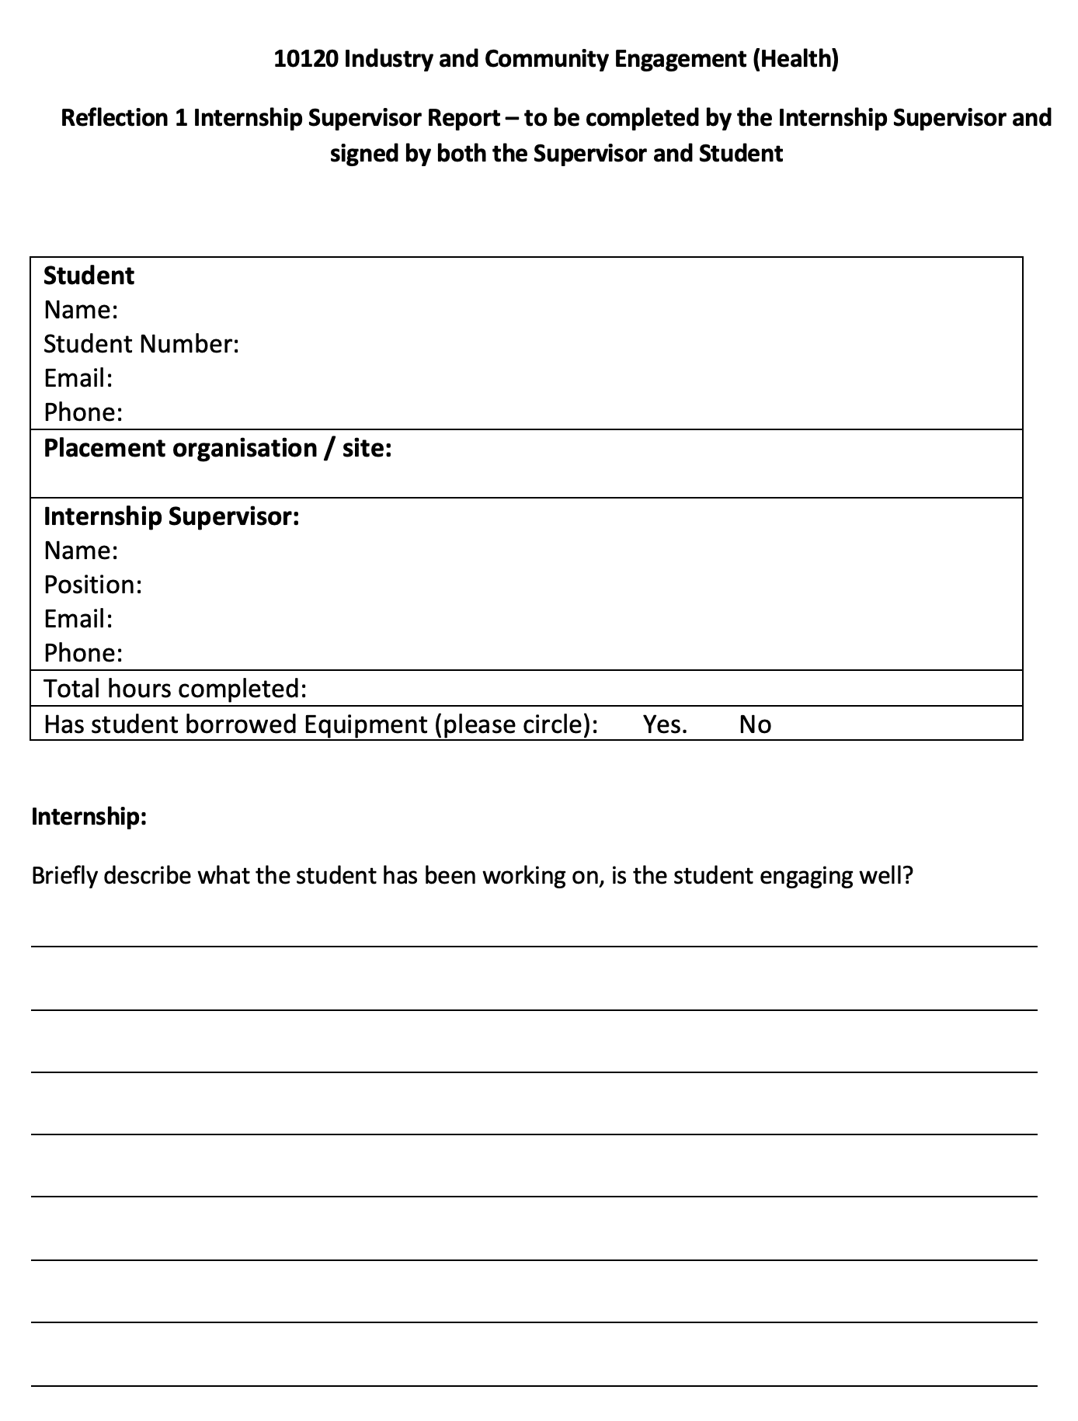
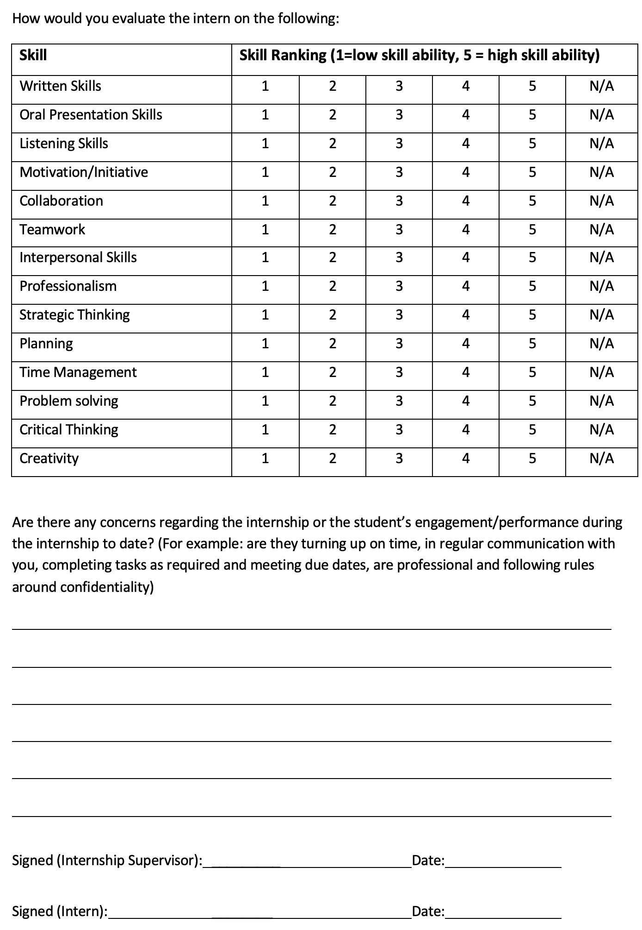

ATTACHMENT 8: Marking Rubric: ePortfolio

